**Client: Scalawags Veterinary Clinic**



**Kevin Yang**

**John Beguhl**

**Zuhair Rauf**

**Yannan Zhu**

**Jisung Woo**

**Scalawags Veterinary Clinic EERD**

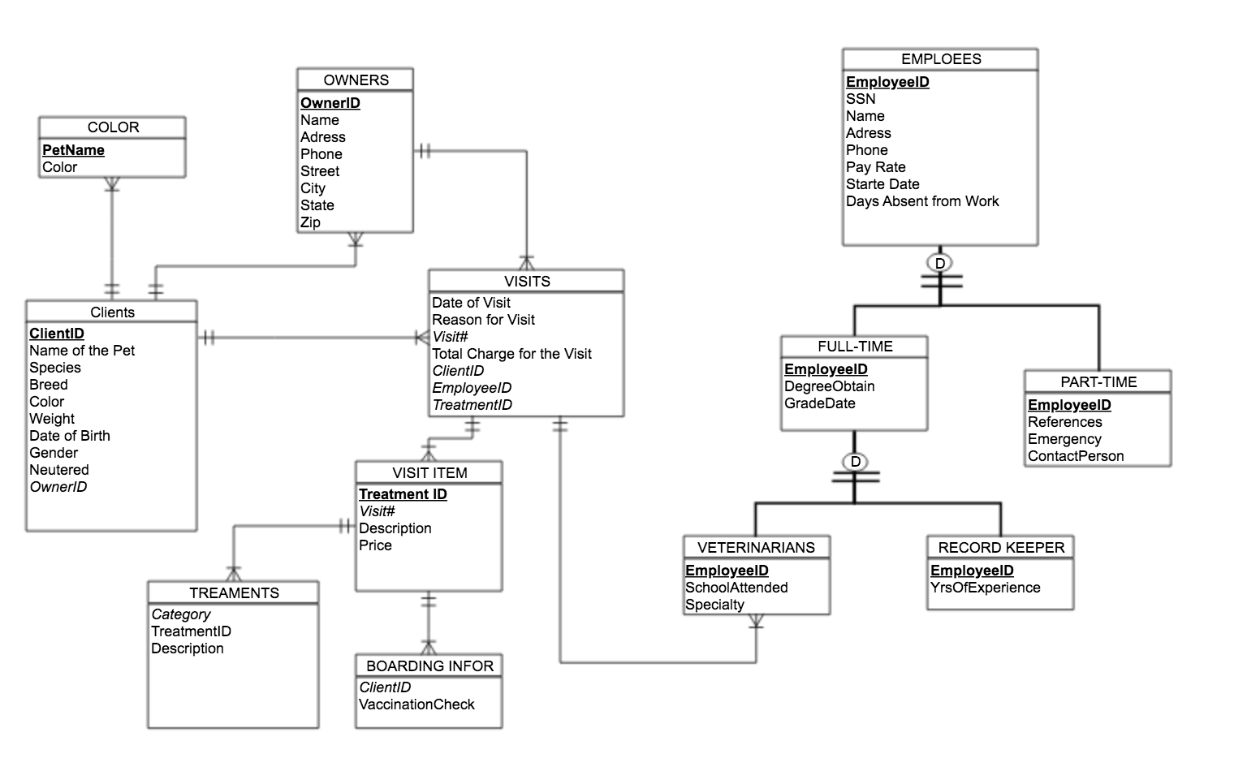

Jw JB

**Data Dictionary Entries**

|  |  |  |
| --- | --- | --- |
| ***Entity*** | ***Attributes*** | ***Definition*** |
| VISITS | Date of Visit | Each 2-digit number represents day, month, and year. The data should be formed as Month/Day/Year, eg. 01/01/2019. |
| VISITS | Reason for Visit | Reason for visit max length 50 chars (eg. for diagnoses, for procedures, for medical goods and services) |
| VISITS | *Visit#* | 3 character code and 4 digit number uniquely identifying the visits, assigned by Scalawags Veterinary Clinic |
| VISITS | Total Charge for the Visits | The total cost of visit, New registrants start at $0.00; 2 decimal places |
| VISITS | *ClientID* | 4-digit number uniquely identifying the client, assigned by Scalawags Veterinary Clinic |
| VISITS | *EmployeeID* | 2-digit number uniquely identifying the employee, assigned by Scalawags Veterinary Clinic |
| VISITS | *TreatmentID* | 5-digit number uniquely identifying the treatment, assigned by Scalawags Veterinary Clinic |
| VISIT ITEM | ***TreatmentID*** | 5-digit number uniquely identifying the treatment, assigned by Scalawags Veterinary Clinic |
| VISIT ITEM | *Visit#* | 3 character code and 4 digit number uniquely identifying the visits, assigned by Scalawags Veterinary Clinic |
| VISIT ITEM | Description | The detail types of treatment, 3-digit number and character data, 3-digit number starts at 1.01 and ends at 5.01,character data is max-length 30 |
| VISIT ITEM | Price | The cost of treatment, New registrants start at $0.00; 2 decimal places |
| TREATMENTS | *Category* | The types of treatment, character data, max-length 20 |
| TREATMENTS | TreatmentID | 5-digit number uniquely identifying the treatment, assigned by Scalawags Veterinary Clinic |
| TREATMENTS | Description | The detail types of treatment, 3-digit number and character data, 3-digit number starts at 1.01 and ends 5.01,character data is max-length 30 |
| BOARDING INFO | *ClientID* | 4-digit number uniquely identifying the client, assigned by Scalawags Veterinary Clinic |
| BOARDING INFO | VaccinationCheck | Vaccinations are for dogs and cats, character data, max-length 30 |
| CLIENT | **ClientID** | 4-digit number uniquely identifying the client, assigned by Scalawags Veterinary Clinic |
| CLIENT | Name of the Pet | (required), character data, max-length 30 |
| CLIENT | Species | The species of pets, character data, max-length 10 |
| CLIENT | Breed | The breed of pets, character data, max-length 20 |
| CLIENT | Color | The color(s) of the pet |
| CLIENT | Weight | The weight of the pet in pounds |
| CLIENT | Date of Birth | Date of birth of the pet in MM/DD/YYYY format. If exact date is not know then the birth month and year will suffice. |
| CLIENT | Gender | M/F |
| CLIENT | Neutered | Y/N |
| CLIENT | *OwnerID* | 4-digit number uniquely identifying the owner, assigned by Scalawags Veterinary Clinic |
| COLOR | **PetName** | (required), character data, max-length 30 |
| COLOR | Color | The color(s) of the pet |
| EMPLOYEES | **EmployeeID** | 2-digit number uniquely identifying the employee, assigned by Scalawags Veterinary Clinic |
| EMPLOYEES | SSN | 8-digit Social Security Number of the employee |
| EMPLOYEES | Name | Name of the employee |
| EMPLOYEES | Address | Address of the employee |
| EMPLOYEES | Phone | Phone number of the employee, max length 10 |
| EMPLOYEES | PayRate | Pay rate of the employee given by Scalawags Veterinary Clinic in $XX.XX format |
| EMPLOYEES | StartDate | Official start date of the employee in MM/DD/YYYY format |
| EMPLOYEES | Days Absent from Work | The amount of days the employee has been absent from work |
| FULL-TIME | **EmployeeID** | 2-digit number uniquely identifying the employee, assigned by Scalawags Veterinary Clinic |
| FULL-TIME | DegreeObtain | BA/BS, MA/MS, PHD (Bachelor of Arts/ Bachelor of Science, Master of Arts/ Master of Science, Doctoral) |
| FULL-TIME | GradeDate | Grad Date in MM/DD/YYYY format. |
| PART-TIME | **EmployeeID** | 2-digit number uniquely identifying the employee, assigned by Scalawags Veterinary Clinic |
| PART-TIME | References | References in first name initial and last name format. (eg. J.Smith) |
| PART-TIME | Emergency | Emergency contact, max length 10 (xxx-xxx-xxxx) |
| PART-TIME | **ContactPerson** | Contact Person in first name initial and last name format. (eg. J.Smith) |
| VETERINARIANS | EmployeeID | 2-digit number uniquely identifying the employee, assigned by Scalawags Veterinary Clinic |
| VETERINARIANS | SchoolAttended | School Attended in colloquial names for universities and colleges format(eg. ASU Arizona State University) |
| VETERINARIANS | Speciality | 22 recognized veterinary specialties, max length 35 chars (eg. Toxicology) |
| RECORD-KEEPER | **EmployeeID** | 2-digit number uniquely identifying the employee, assigned by Scalawags Veterinary Clinic |
| RECORD-KEEPER | YrsOfExperience | 2-digit number, (0-99) |
| OWNERS | **OwnerID** | 4-digit number uniquely identifying the owner, assigned by Scalawags Veterinary Clinic |
| OWNERS | Name | First Name (Max length 35 chars), Last Name (Max length 35 chars) |
| OWNERS | Address | Address format (Street, City, State, Zip) |
| OWNERS | Phone | Phone number of the owner, max length 10 (xxx-xxx-xxxx) |
| OWNERS | Street | Street name max length 35 chars |
| OWNERS | City | Max-length 28 chars |
| OWNERS | State | State in U.S. State Postal Abbreviations format. (eg. AZ Arizona) |
| OWNER | Zip | Zip is a 5-digit code (max length 9) |

**JB**

**Journals**

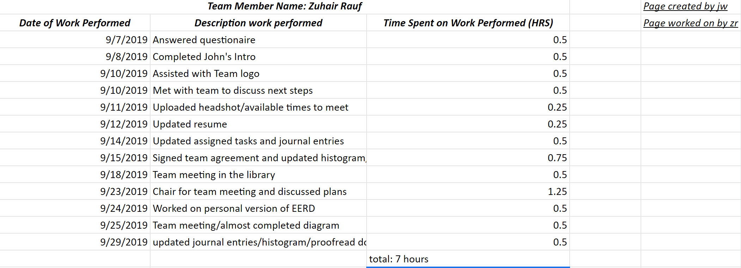

|  |  |  |
| --- | --- | --- |
| ***Team Member Name: Kevin Yang*** | | |
| ***Date of Work Performed*** | ***Description work performed*** | ***Time Spent on Work Performed (HRS)*** |
| 9/6 2019 | Answered team questionaire for member introduction | 1 |
| 9/10 2019 | Team meeting | 0.25 |
| 9/11 2019 | Write introduction for myself | 1 |
| 9/12 2019 | Team logo development (image editing) | 0.2 |
| 9/14 2019 | Update team profile | 0.1 |
| 9/14 2019 | Upload resume to team google doc | 0.2 |
| 9/14 2019 | Upload headshot to team google doc | 0.7 |
| 9/14 2019 | Update histogram | 0.1 |
| 9/14 2019 | Upload group availability schedule to team google doc | 0.2 |
| 9/14 2019 | Update assigned tasks on team google doc | 0.3 |
| 9/15 2019 | Create chart for team histogram | 0.5 |
| 9/15 2019 | Put initial on pages worked on | 0.25 |
| 9/15 2019 | Upload Journal Entry to team google doc | 0.1 |
| 9/15 2019 | Check font and formatting on document | 0.1 |
|  | Total Hours(9/6 ~ 9/15): | 5 |
| 9/18 2019 | Team Meeting | 0.25 |
| 9/23 2019 | Team Meeting | 1.1 |
| 9/25 2019 | Office Hour (ERD) | 1 |
| 9/25 2019 | Team Meeting | 0.5 |
| 9/28 2019 | Recreate Team Histogram | 0.167 |
| 9/28 2019 | Update Histogram | 0.167 |
| 9/28 2019 | Data dictionary definiton | 1 |
| 9/29 2019 | Update Histogram | 0.05 |
| 9/29 2019 | Upload Journal Entry to team google doc | 0.05 |
|  | Total Hours(9/18 ~ 9/29): | 4.284 |

|  |  |  |
| --- | --- | --- |
| ***Team Member Name: Jisung Woo*** | | |
| ***Date of Work Performed*** | ***Description work performed*** | ***Time Spent on Work Performed (HRS)*** |
| 8/29/2019 | Gathered Team's information | 0.2 |
| 8/29/2019 | Created Milestone 1 Google Drive Folder and Document | 0.1 |
| 9/7/2019 | Answered 15 questions from "100 getting to know you questions" | 1 |
| 9/8/2019 | Wrote Yannan Zhu's introduction | 1 |
| 9/10/2019 | Had a team meeting (arrived late) | 0.17 |
| 9/10/2019 | Created Title Page and researched for suitable logo | 0.5 |
| 9/10/2019 | Created multiple documents, Agenda, Individual Journal Entries, Logo ideas, and resource Histogram | 2 |
| 9/11/2019 | Declared for chair position | 0.02 |
| 9/11/2019 | Edited Meeting Agenda for both 8/29/2019 and 9/10/2019 | 1.5 |
| 9/11/2019 | Updated and uploaded my resume and pictures | 0.75 |
| 9/11/2019 | Edited Team Profile section on Milestone one | 0.25 |
| 9/11/2019 | Updated Resource Histogram | 0.1 |
| 9/12/2019 | Reviewed and Signed Team Agreement | 0.2 |
| 9/13/2019 | Complete "when to meet" website | 0.083 |
| 9/14/2019 | Finalized Meeting Agendas | 0.5 |
| 9/14/2019 | Made sure if all documents were in correct format and correct font | 0.05 |
| 9/14/2019 | Added consequences section on Team Agreement document | 0.17 |
| 9/15/2019 | Finished "Assigned Tasks" section on Milestone 1 | 0.017 |
| 9/15/2019 | Wrote my initials on the pages that I've created and/or worked on | 0.17 |
| 9/15/2019 | Gave team warning on what is still missing from certain people and need in better communication | 0.17 |
| 9/18/2019 | Team Meeting | 0.5 |
| 9/18/2019 | Re-create Individual Journal Entries | 0.083 |
| 9/18/2019 | Re-create Unedited Version of Meeting Agenda | 0.083 |
| 9/21/2019 | Milestone 2 Outline on my own | 0.5 |
| 9/23/2019 | Team Meeting | 1.25 |
| 9/23/2019 | Created and edited "Questions for Office Hour/Tutoring Center" | 0.167 |
| 9/24/2019 | Create my own draft of EERD | 0.5 |
| 9/25/2019 | Create a separate document and upload EERD (because I won't be able to attend the meeting) | 0.083 |
| 9/27/2019 | Created data dictionary and worked on it | 0.75 |
| 9/28/2019 | Slightly edited Data Dictionary | 0.167 |
| 9/28/2019 | Fixed minor issues from the team meeting document | 0.0167 |
| 9/28/2019 | Edited on Team16-M2 | 0.167 |
| 9/29/2019 | Updated and uploaded Individual Journal Entries and Resource Histogram Proofread Document | 0.15 |
|  | Total Hours | 13.25 |

|  |  |  |
| --- | --- | --- |
| ***Team Member Name: Yannan Zhu*** | | |
| ***Date of Work Performed*** | ***Description work performed*** | ***Time Spent on Work Performed (HRS)*** |
| 9/8/2019 | Answered 15 questions about myself | 1 |
| 9/8/2019 | Wrote Jisung's introduction | 1 |
| 9/14/2019 | Upload the resume | 0.5 |
| 9/14/2019 | Upload the headshot | 0.5 |
| 9/14/2019 | Update histogram | 0.4 |
| 9/14/2019 | Update Agenda | 0.2 |
| 9/15/2016 | Updated assigned tasks and journal entries | 0.2 |
|  | Total hours(9/8 - 9/15): | 3.8 |
| 9/18/2019 | Team Meeting | 0.5 |
| 9/22/2019 | Create the first draft of ERD | 0.33 |
| 9/23/2019 | Create the "Milestone 2" document | 0.083 |
| 9/23/2019 | Team Meeting | 1.25 |
| 9/25/2019 | Office hours | 1 |
| 9/25/2019 | Team Meeting | 0.5 |
| 9/25/2019 | Create the detail about ERD and upload | 0.17 |
| 9/27/2019 | Data dictionary definition | 1 |
| 9/29/2019 | Update the journal entry | 0.16 |
|  | Total hours(9/18 - 9/29): | 4.993 |
|  | Total hours(9/8 - 9/29): | 8.793 |

**ZR**

**Histogram**

